**Add the Pride M365 Photo Update PowerApp to your tenant and to Teams.**

1. Download the PowerApps template .zip here : <https://github.com/takotsop/M365PhotoUpdateTemplate>
2. Visit https://powerapps.microsoft.com and sign in.
3. On the left pane, select Apps
   1. 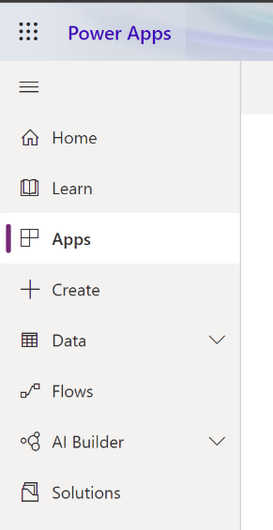
4. At the top, select Import Canvas App
   1. 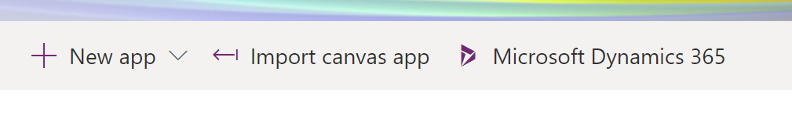
5. Upload the .zip you downloaded in step 1.
6. When its finished uploading you will see this page, select “Create as New” to give it a name.
   1. 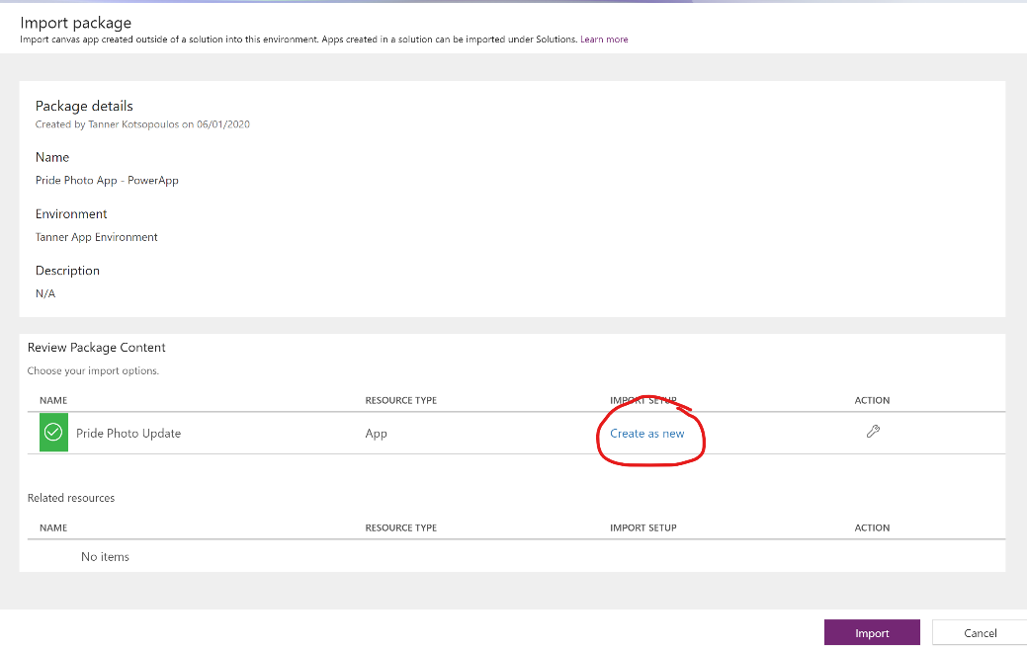
   2. Keep it as “create as new” and give it a name in the blade that opens.
7. Then Select Import. Once this is finished, you should see your app show up in the app menu within a few minutes.
8. You need to share the app through the PowerApps Website, and if you’d like to make any changes you can edit the App as well.
   1. Best to share to the company ALL distribution (search for “everyone”) for PowerApps so everyone gains access. You can then copy the link and share it broadly.

**Creating new filters**

1. New filters should be a transparent square .png file, roughly 1000px x 1000px.
2. These files get uploaded into File -> Media, and then referenced in the application by their media name.
   1. 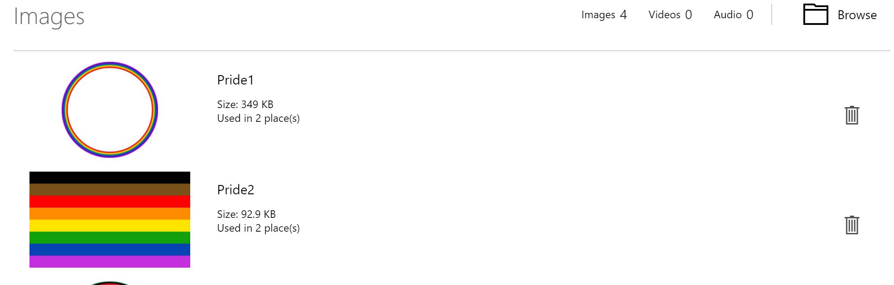
   2. 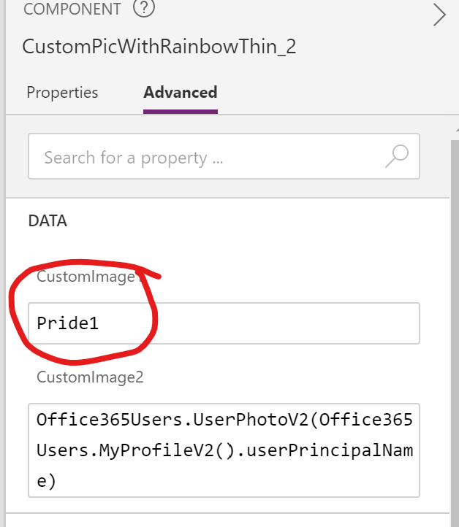

**Want to share and pin this app for your organization using the Microsoft Teams left rail?**

1. On the Apps page on the PowerApps site. Select your Pride Photo Update app in the list
   1. 
2. The top bar updates and you can select “Add to Teams” to download the .zip package needed to upload a custom app in teams.
   1. 
3. **The following steps need to be completed by a Teams Administrator, to make it available for your organization.**
4. On Teams, go to the App Store, and click “Upload a custom app”
   1. 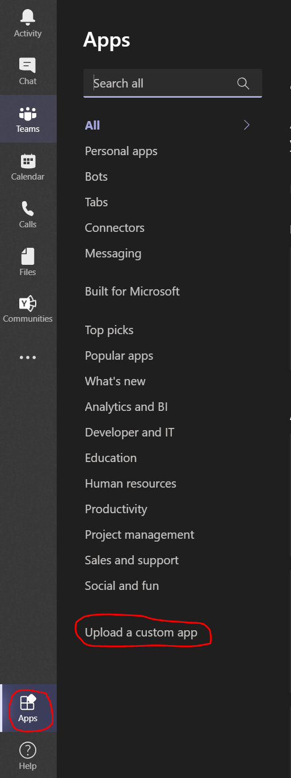
5. Select your PowerApp’s Teams .zip download, and upload for your organization (admin privileges needed)
6. Go to the admin portal at admin.teams.microsoft.com
7. Click on Teams Apps > Setup Policies
8. Select the policy/user group you want to pin the app for (default global)
9. Click Add apps, and add your app. Order it how you would like and save.